**Name: Session:**

**Programming II**

**Lab Exercise 2.19.2020 Stardate: 73136.61**

1. The following table lists 6 states and their official abbreviation.

|  |  |
| --- | --- |
| **State** | **Abbreviation** |
| Virginia | VA |
| North Carolina | NC |
| South Carolina | SC |
| Georgia | GA |
| Alabama | AL |
| Florida | FL |

Create an application that allows the user to select a state, and then displays the state’s official abbreviation. Hint: the form should have 6 buttons and 1 label.

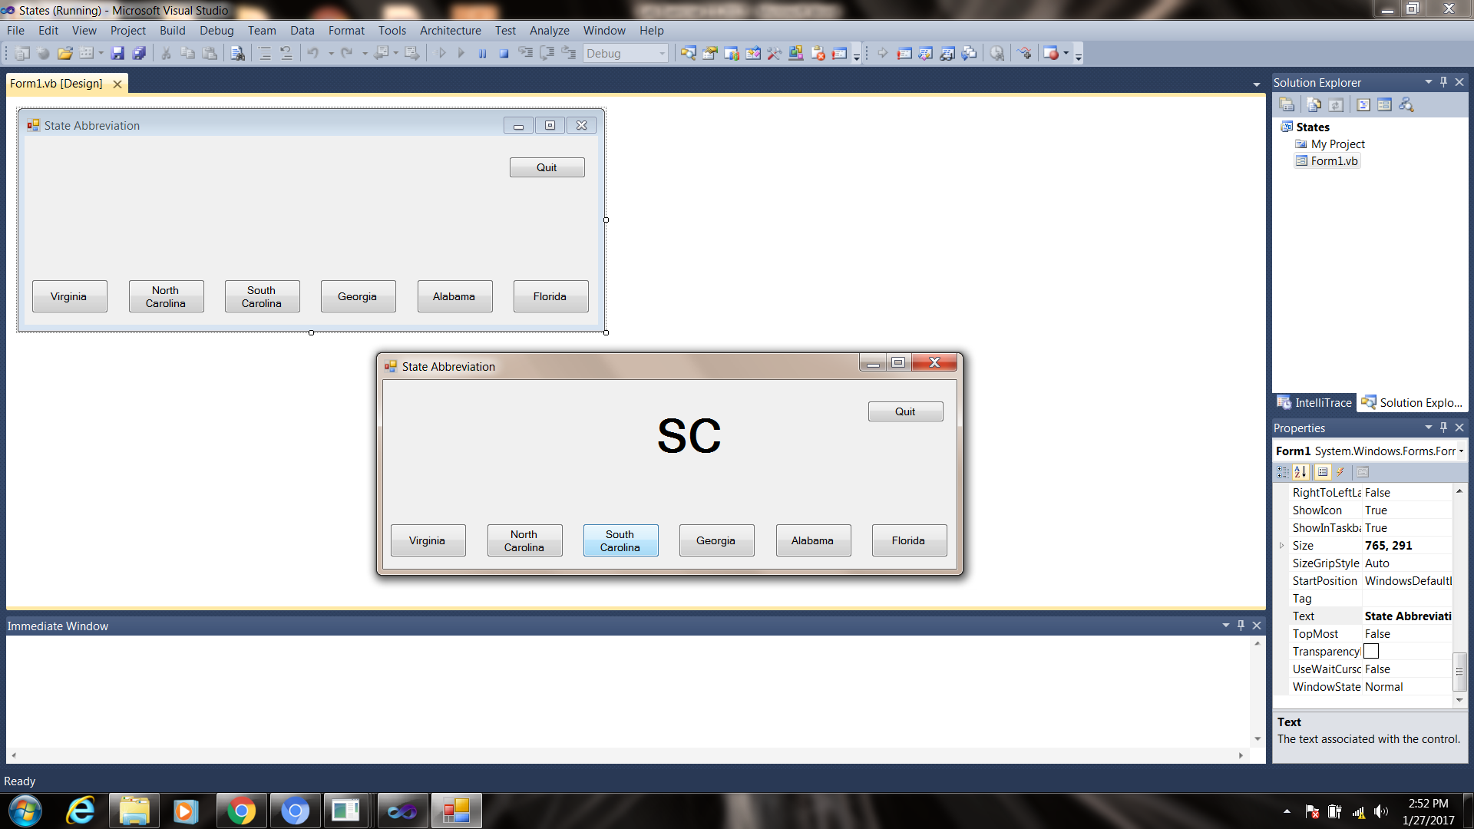

1. A joke typically has two parts: a setup and a punch line. For example, this might be a setup for a joke:

How many programmers does it take to change a lightbulb?

and the punch line:

None. That’s a hardware problem.

Think of your favorite joke that has a Setup button and a Punch Line button that displays in a label.

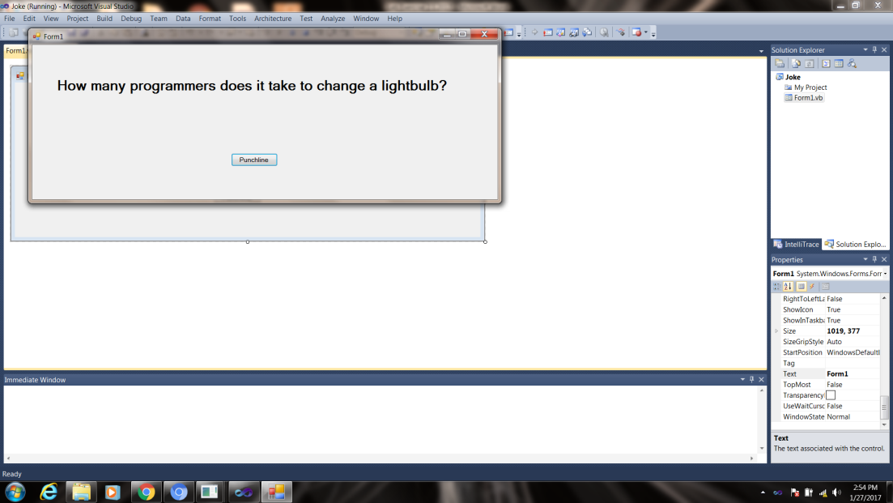 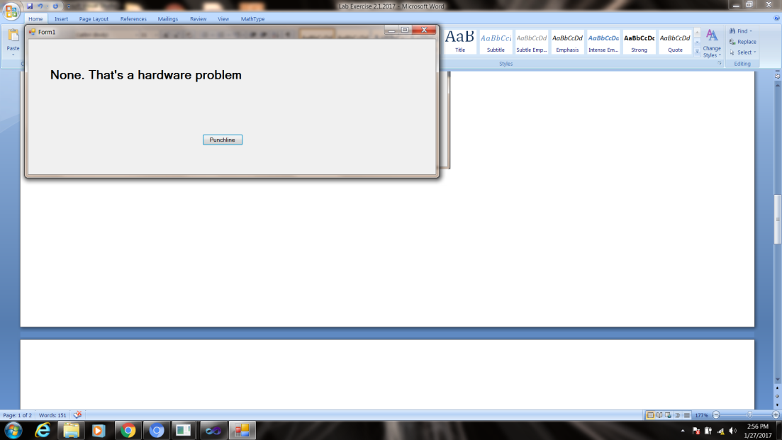

**When you have completed these three applications, print out your source code and a screen shot of your running application, attach it to this sheet and turn in.**